**Name : Aatmaj Mhatre**

**Roll No.: 16010121110**

**Batch: C2**

**Experiment No. 01**

1 . WPA for 3 Array Methods

let array1 = [1, 2, 3];

let array2 = [4, 5];

array1.push(4, 5);

console.log("array1 after push:", array1);

let removedElement = array1.pop();

console.log("Removed element from array1:", removedElement);

const array3 = ['6', '7', '9'];

let size = array3.length;

console.log("length", size);

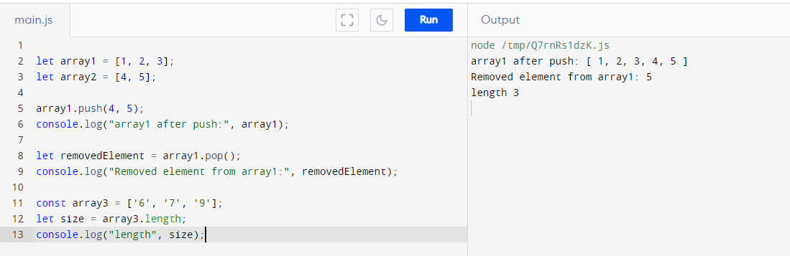

2. WAP for data method

// Note: Months are 0-based, so January is 0, February is 1, and so on.

// Adding 1 to the month to display the correct value

// Create a new Date object representing the current date and time

let currentDate = new Date();

// Get various components of the date

let year = currentDate.getFullYear();

let month = currentDate.getMonth();

let day = currentDate.getDate();

let hours = currentDate.getHours();

let minutes = currentDate.getMinutes();

let seconds = currentDate.getSeconds();

// Format the date and time for display

let formattedDate = `${year}-${month + 1}-${day}`;

let formattedTime = `${hours}:${minutes}:${seconds}`;

// Output the results

console.log("Current date:", formattedDate);

console.log("Current time:", formattedTime);

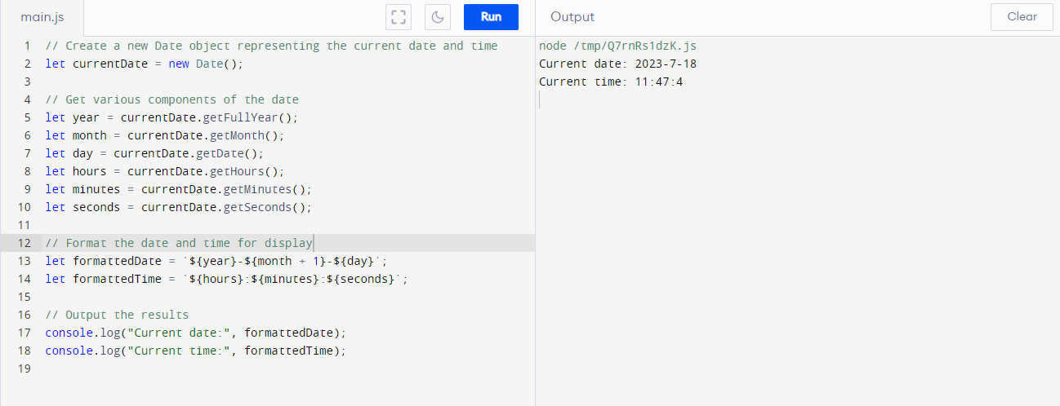

3. WAP to implement any three string methods

// Function to find the length of a string

function length(str) {

return str.length;

}

let text = "Hello, World!";

let len = length(text);

console.log("Length of the string:", len);

// Function to extract a substring from a given string

function substring(str, start, length) {

return str.substring(start, start + length);

}

let sub = substring(text, 0, 5);

console.log("Substring:", sub);

// Function to find the first occurrence of a substring in a string

function indexOf(str, sub) {

return str.indexOf(sub);

}

let pos = indexOf(text, "World");

if (pos !== -1) {

console.log("Found at position:", pos);

} else {

console.log("Substring not found!");

}

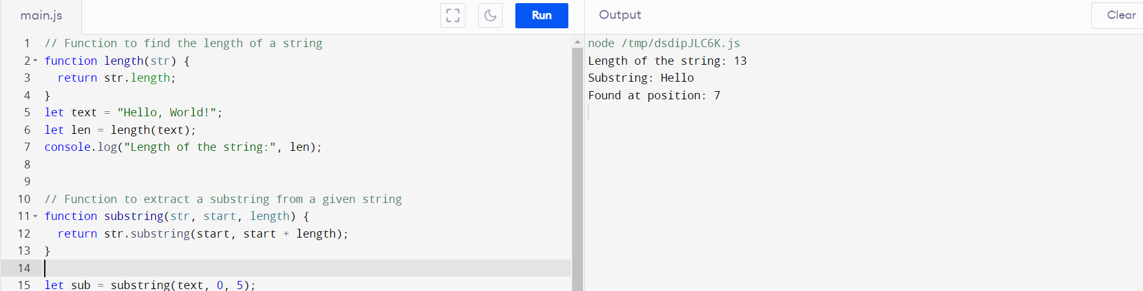

4. WAP for browser specific code

<!DOCTYPE html>

<html>

<head>

  <title>Browser-Specific Code</title>

</head>

<body>

  <h1>Heyy!! Code is working </h1>

  <script>

    const isChrome = /Chrome/.test(navigator.userAgent) && /Google Inc/.test(navigator.vendor);

    if (isChrome) {

      console.log("This code is running in Chrome browser.");

    } else {

      console.log("This code is running in a non-Chrome browser.");

}

  </script>

</body>

</html>

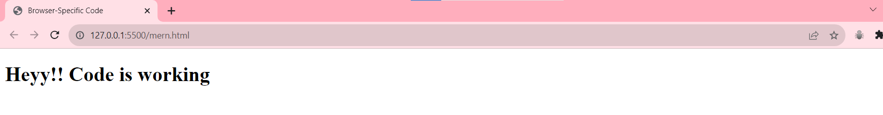

**Lab Practice Work : -**

**WAP for various operation in js**

let x = 5;

let y = 2;

console.log("Addition ", x + y );

console.log("subtraction ", x - y );

console.log("multiplication ", x * y );

console.log("division ", x / y );

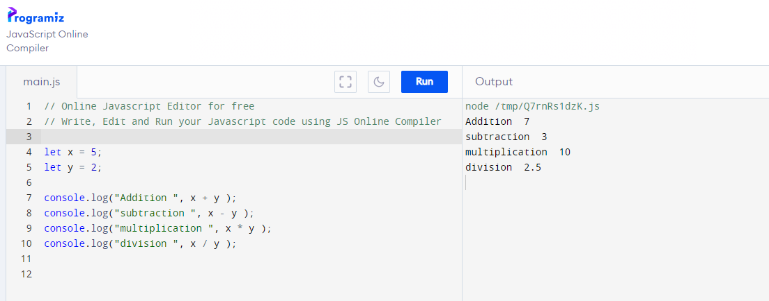

**WAP for different array function**

**// Regular function declaration to add two numbers**

function addNumbers(a, b)

{return a + b;}

**// Arrow function to subtract two numbers**

const subtractNumbers = (a, b) => a - b;

**// Higher-order function that takes a function as an argument**

function calculate(operation, num1, num2)

{return operation(num1,num2);}

**// Function expression to multiply two numbers**

const multiplyNumbers = function (a, b)

{ return a * b; };

**// Function calls**

console.log("Addition:", addNumbers(5, 3));

console.log("Subtraction:", subtractNumbers(10, 4));

console.log("Multiplication:", multiplyNumbers(2, 6));

console.log("Result of calculate (addition):", calculate(addNumbers, 8, 2));

console.log("Result of calculate (subtraction):", calculate(subtractNumbers, 10,3));

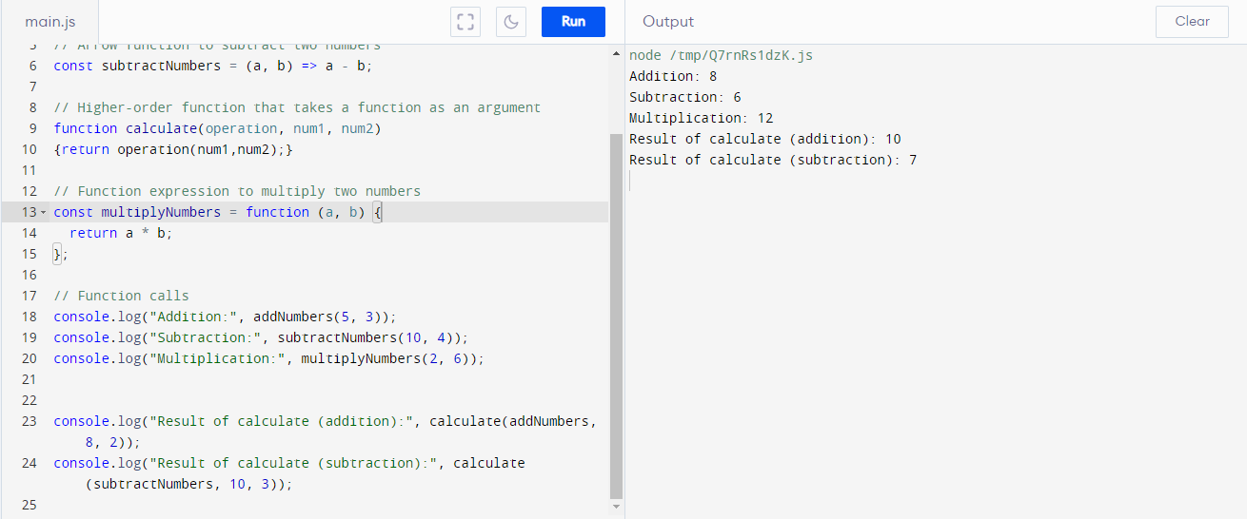

1. Write a program to print the Content of the page with customized settings

<!DOCTYPE html>

<html>

<head>

  <title>Print Page with Customized Settings</title>

</head>

<body>

  <h1>Hello, this is the content of the page!</h1>

  <p>This is an example paragraph.</p>

  <button id="printButton">Print this page</button>

  <script>

    const printButton = document.getElementById("printButton");

    printButton.addEventListener("click", function () {

      window.print();

    });

  </script>

</body>

</html>

Output :

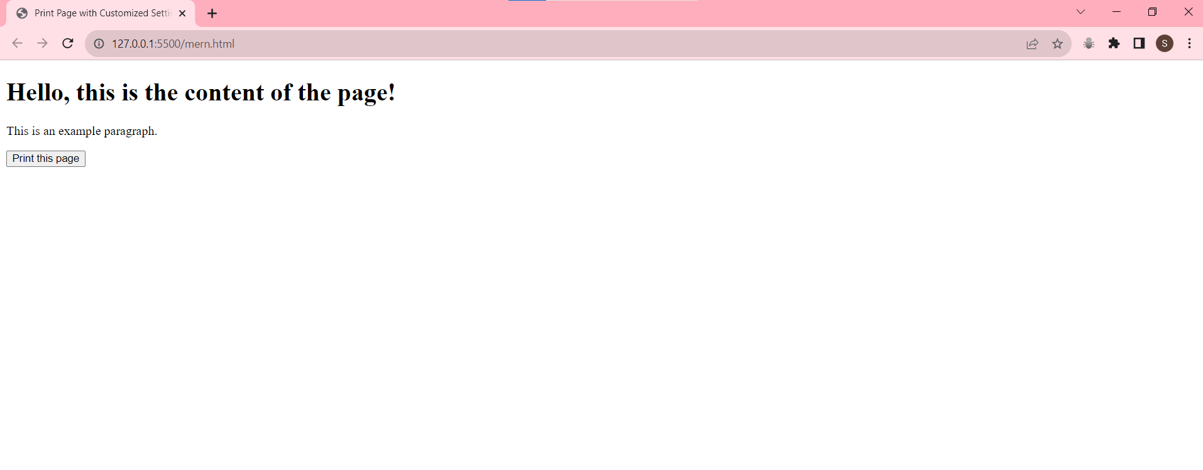

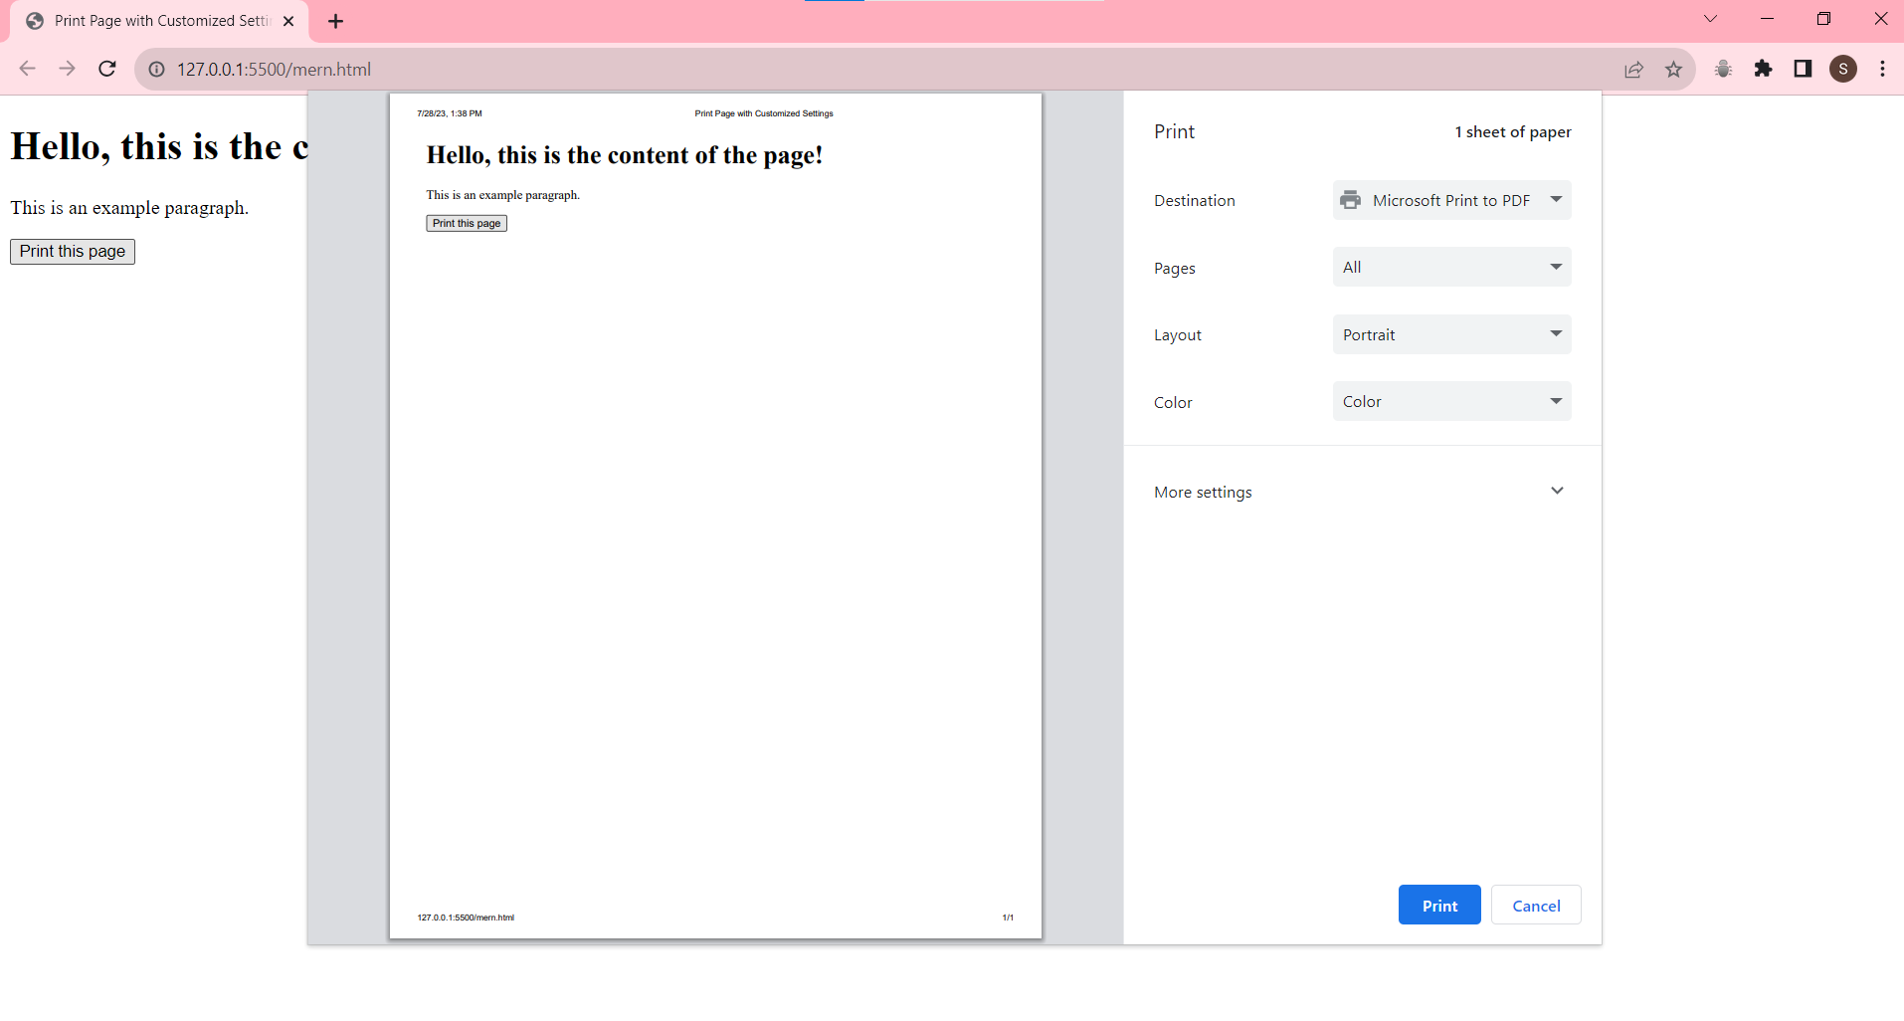

2. Write a program to implement forms

3. Write a program to implement browser specific window

**function validateForm() {**

**let x = document.forms["myForm"]["fname"].value;**

**if (!x.match("[@][a-z]+[.]com$")) {**

**alert("invalid email");**

**return false;**

**}**

**myPrint(x);**

**}**

**if(agentHas("Firefox") || agentHas("FxiOS") || agentHas("Focus")){**

**window.alert("Firefox is being used")**

**}**

**else if( agentHas("CriOS") || agentHas("Chrome") || !!window.chrome){**

**window.alert("Windows is being used")**

**}**

**function agentHas(keyword) {**

**return navigator.userAgent.toLowerCase().search(keyword.toLowerCase()) > -1;**

**}**

**window.onload = function(){**

**document.getElementById("id").innerHTML = document.querySelector("#id").innerHTML+ "!"**

**}**

**function myPrint(data) {**

**newwin = window.open("");**

**newwin.document.write(data);**

**newwin.print();**

**newwin.close();**

**}**

**<html>**

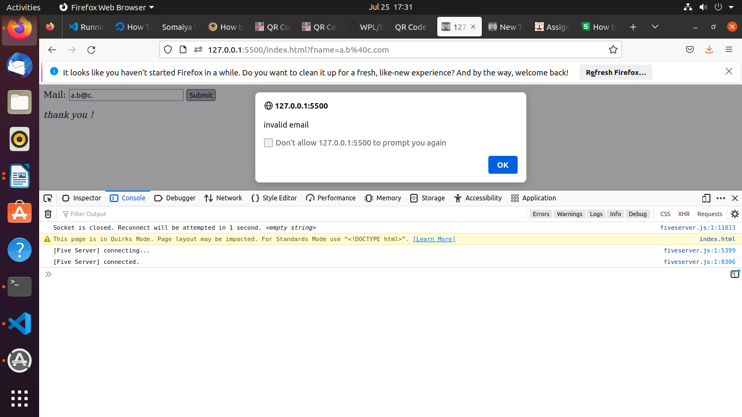**<form name="myForm" id="myfom" onsubmit="validateForm()">**

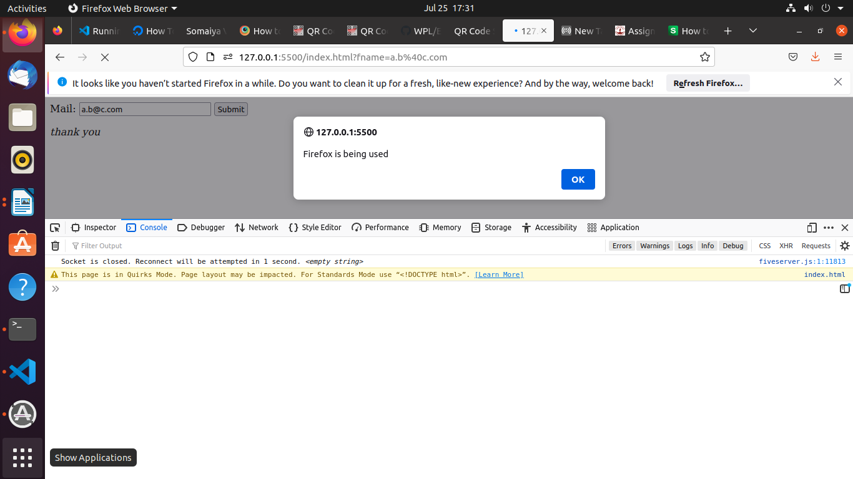**Mail: <input type="text" name="fname">**

**<input type="submit" value="Submit">**

**</form>**

**<i class="abcd" id="id" name="xyz">thank you </i>**

**<script src="./app.js"></script>**

**</html>**



